Report Analytical Functions

Aliaksandr Labayeu

# Task 1

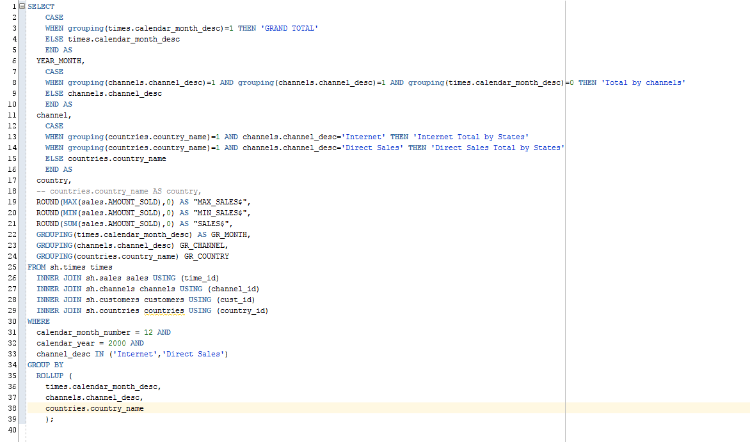

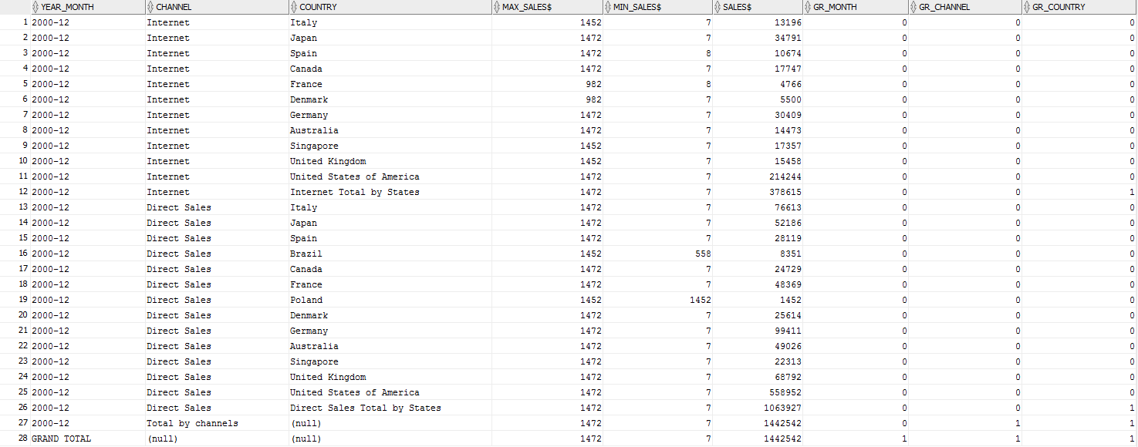

Export in Excel

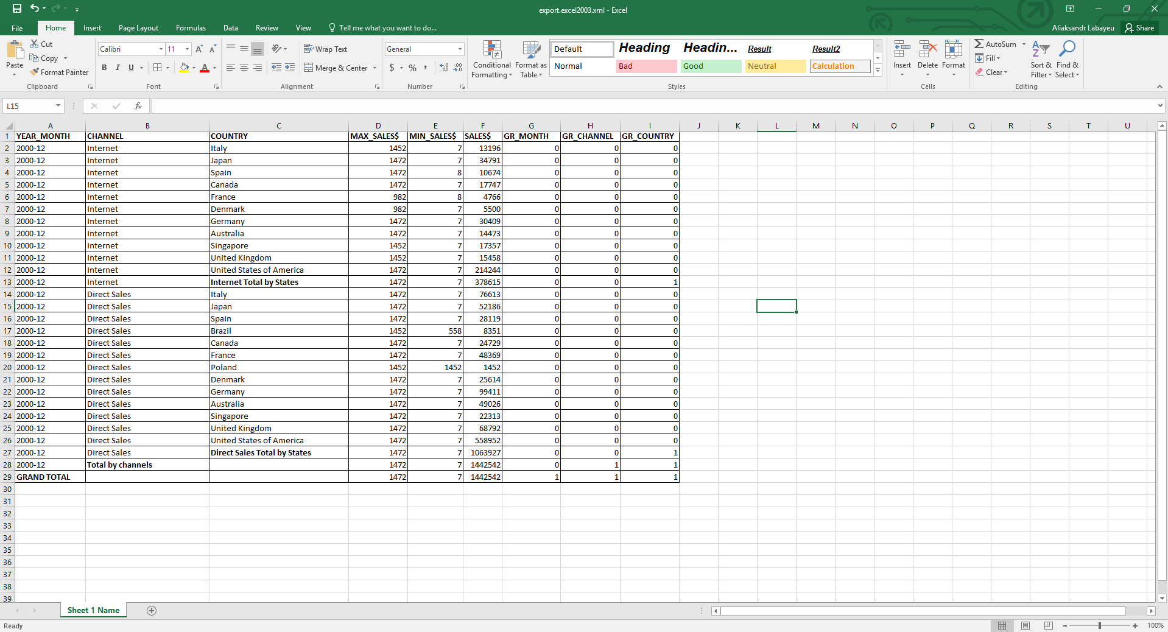

# Task 2

1st variant with NTH_VALUE function

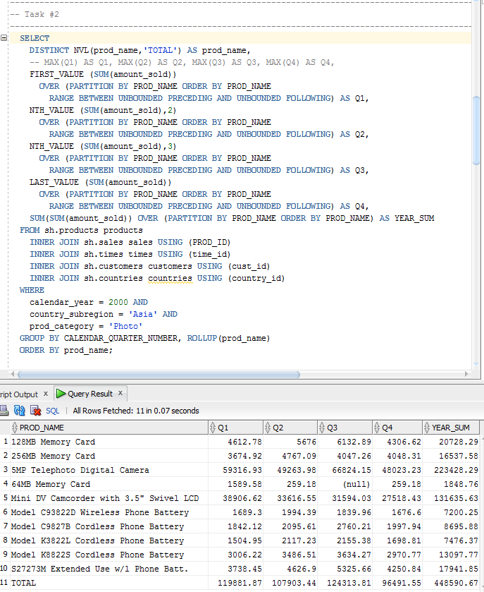

2nd variant with PIVOT function

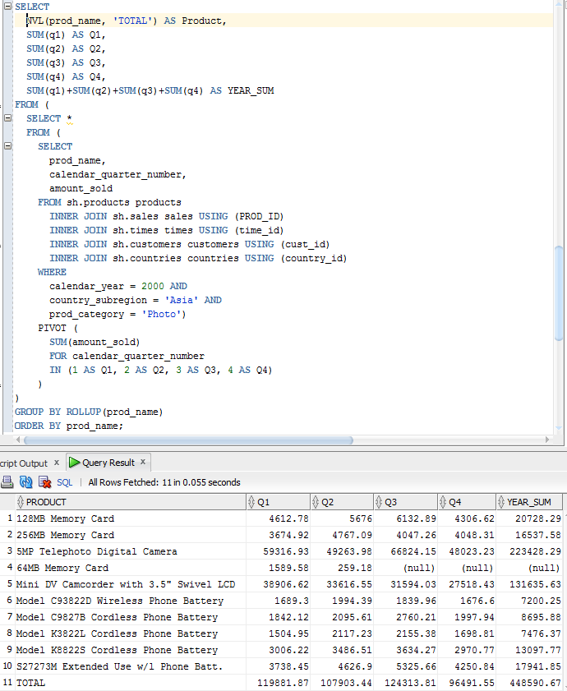

# Task №3

Task 3 task was set as:

* Find total quantity sold by countirs in EUROPE region for 1998 year per quarter where every country will be set as a row of the table.

Result:

